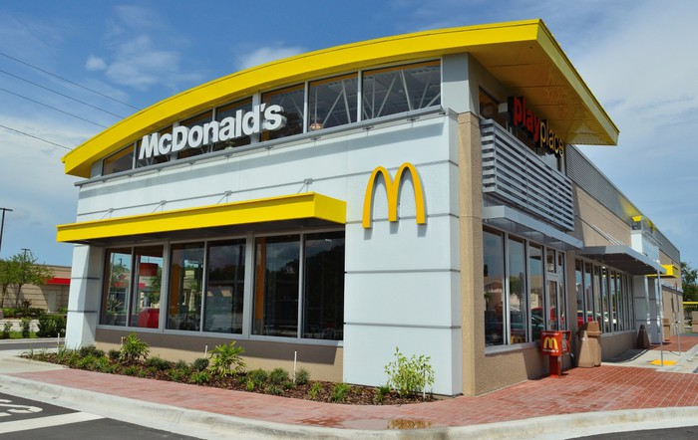
McDonald's: Strengths, Weaknesses, Opportunities, Threats

McDonald's serves up burgers, smoothies, coffee and new highs.
McDonald's has been outperforming the market this year and recently set a new all-time high. A SWOT analysis -- a look at strengths, weaknesses, opportunities, and threats -- can help assess whether the fast-food giant can keep the growth on a high-calorie diet.
Strengths:
- The second-largest restaurant network serving customers in over 120 countries
- As of 2018, McDonald’s operates the second-largest restaurant network in the world. In total, the company and its franchisees operate 37,241 restaurants in 120 countries.
- Wide audience reach. McDonald’s restaurant network allows the chain to reach more customers than most of its rivals could reach. According to the Company’s CEO[6], in five of its largest markets, 75% of population lives within 3 miles of McDonald’s restaurants.
- With a strong product offering, the company has grown income throughout the recession, notching strong increases in same-store sales.
- Operations are spread around the world, meaning the company is not exposed to just one currency or economy.
Weaknesses:
- It will be harder and harder to find prime locations to build a set of golden arches. The U.S. is saturated with its restaurants, so growth will have to occur internationally, posing potential cultural challenges.
- While the annual dividend hikes are likely to continue, the dividend growth rate has been slowing and will probably continue to slow or level off.
Opportunities:
- There are opportunities for new restaurants outside the United States, China is a great opportunity for the company, as is much of Asia.
- Menu innovations are limited only by imagination.
- Low interest rates provide cheap capital for growth. In addition to dollar-denominated debt, McDonald's recently became the first foreign company to issue yuan-denominated bonds in Hong Kong.
Threats:
- Governments are considering regulations targeting fast food.
- McDonald's faces competition from strong peers such as recent Yum! Brands and Burger King.
- New product rollouts often have to go head-to-head with established players like Starbucks coffee or Jamba smoothies
- Commodity price increases could increase costs while a weak economy limits the ability to pass the price hikes through to consumers.

